Lesson 15 – Hands on Modular Problem Solving
Problem Solving Exercise
You are designing a self-checkout system at a grocery store. A customer must be able to scan a barcode on the system, and the program will keep track of the total. The program will wait for two forms of input: either the user scans an item or the “pay now” button is pressed. Once the “pay now” button is pressed, the system will calculate the GST (5%) on the total and print the final total to the user. The system accepts three forms of payment: credit card, debit card, or gift card. If the user chooses credit card or debit card, they must be asked to enter a pin, which must be validated with the bank. If the validation fails, the user is asked to try again. Gift cards are always valid. If the validation succeeds, the payment is processed and the order is completed.
This problem is quite complex. There are a lot of moving pieces and requirements. Before writing the pseudocode, we must identify any modules here that can be turned into functions. Remember, a function should be specific with a single purpose, and reusable so that other functions can make use of them if necessary.
Modules:
- Scan – The scanning process. We will repeat this as many times as necessary to complete the order.
- Validate pin – Validate the pin for credit cards and debit cards.
- Validate payment type – Perform the operations necessary to get the payment type and validate that it is correct.
- Process payment – Need to process the payment based on the payment type.

Breaking it Down
There is more than one way to arrive at a solution to creating a modular design for a program.
We could write the entire program then extract the modules into functions. The upside to this is that we can make sure our solution works from start to finish, but the downside is that it takes a lot of time and effort to go back and optimize our code (“refactor”).
The better approach would be to build the application slowly piece by piece building our functions as we go along.
Examining the problem statement shows us that the first step is having the customer scan the items and keeping track of the total as the user scans more items.
We will start with the scanning functionality.
SCANNING
Beginning with the program, develop the scanning functionality without using functions.
1-Main: with scanning functionality
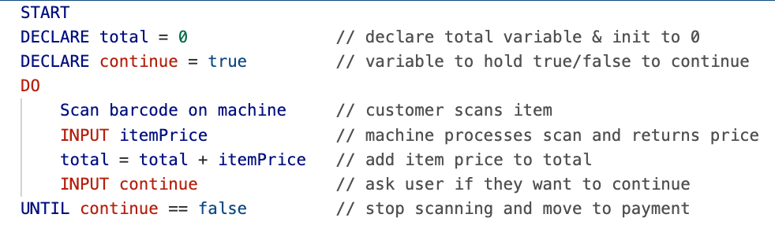
This code is going to work to get our scanning functionality going. We need a variable to hold the total price for the number of items. We need to have steps to scan the item and get the price for each item, and we need to repeat this process until the user decides they are done (continue = false); meaning they pressed Pay Now.
It is possible to modularize parts of this solution. First, we could move our scan functionality to a new function:
2-FUNCTION scan() //scans an item
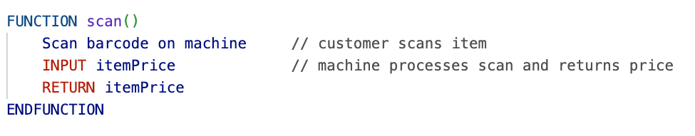
We don’t require any parameters in this function, but we do want to return the item price so that it can be added to the total.
Once the function is created, we can replace the code in the main program with a call to this function instead:
3-MAIN: with FUNCTION scan()
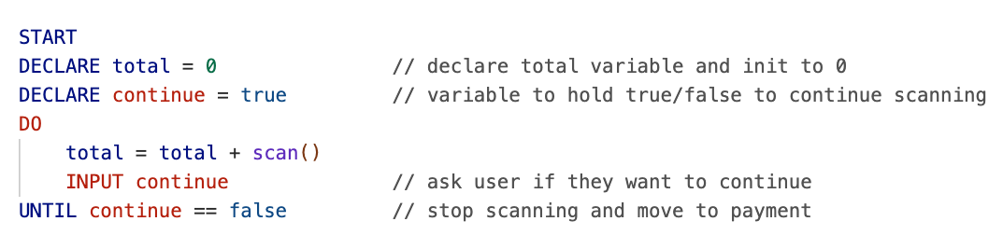
This is a little bit cleaner, and the scan() function can be used in other parts of the program as it scales.
However, we can still improve this first part by creating a scanItems() function, which will contain the code required for scanning all the items. We can also return a total that includes the GST calculation by returning the total * 1.05.
4-FUNCTION scanItems() //scans ALL items and returns total with GST
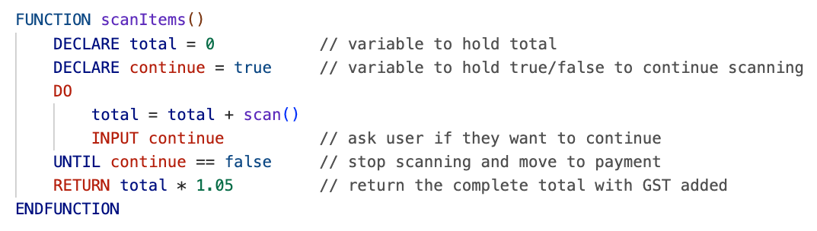
Now with this second function we can really simplify our main program:
5-MAIN: with FUNCTION scanItems()
Notice how we had to declare another “total” variable. This is because the “total” variable that is inside the scanItems() function is out of scope in the main program. If we want to use the value calculated in the scanItems() function, we need to return it and assign it to a new variable.

Validate Payment Type
We have the final total that the customer owes and we are ready to move on to the next phase. We can provide a nice message to the user asking them how they would like to pay followed by any logic required.
6-MAIN: with credit/debit card PIN validation (and FUNCTION scanItems())
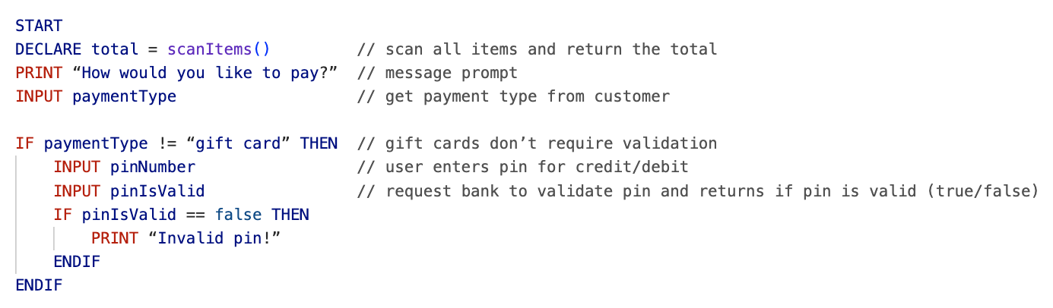
There are a few things that could be improved here. The first one is that the PIN validation could be put into its own function. Creating a function that returns true or false if the pin is valid.
7-FUNCTION validatePin()
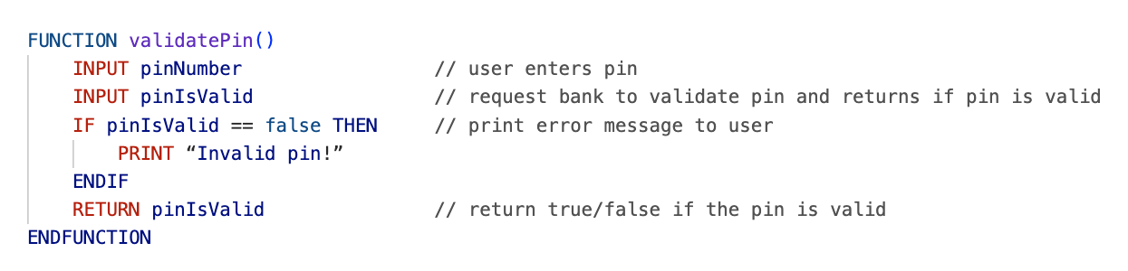
Now we can update our program to look like this:
8-MAIN: with FUNCTION scanItems() and FUNCTION validatePin()
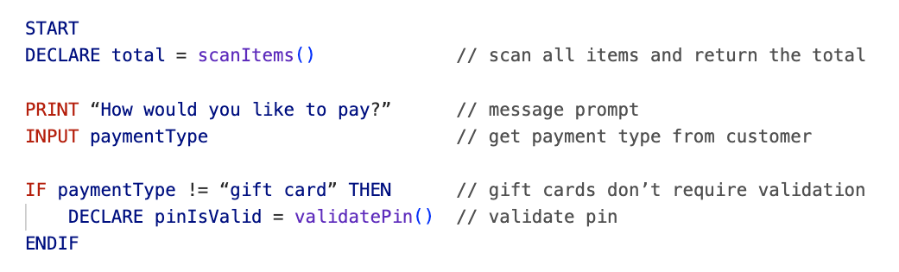
But we are not done yet. According to the requirements, if the payment is invalid, we should re-prompt the user to enter their information. We would need to add DO-UNTIL to our program to accomplish this since we always want to get a payment type at least once.
What would be our exit condition for the DO-UNTIL though? We could create what is known as a “flag”, a Boolean (true/false) variable that detects some sort of change. It is initialized as true/false (depending on the context), then when a criterion of some sort is met, the value flips to its opposite. This is a very common design pattern in software development.
9-MAIN: with payment type validation (and FUNCTION scanItems() and FUNCTION validatePin())
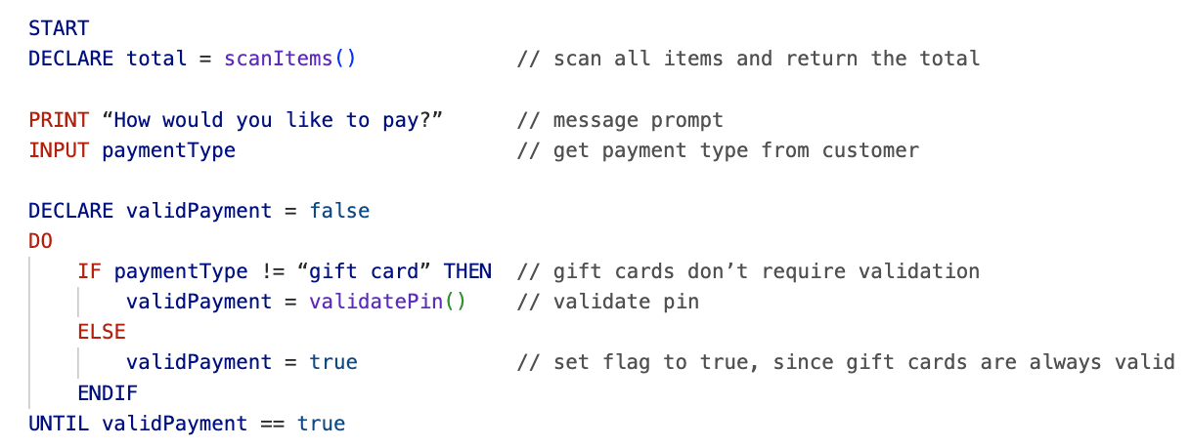
Even now, we could further clean this up in a similar way we did with the scanItems() code. We can put the whole block of code required for getting a valid payment type into another function.

10-FUNCTION validatePaymentType() - uses FUNCTION validatePin()
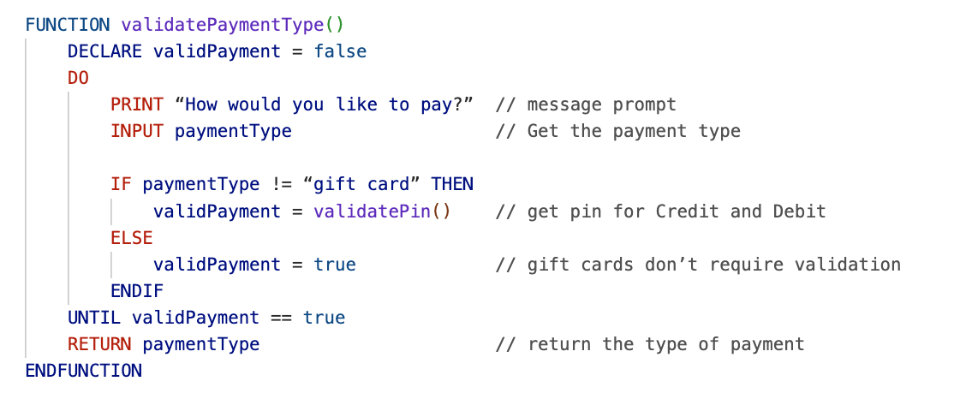
There is one more optimization to our validatePaymentType() function we can make. In our ELSE statement, we set validPayment to true. Instead, we can change the initial value of validPayment to true, then remove the ELSE statement entirely. The reason this will work is because it is a DO-UNTIL, and under certain conditions validPayment could be set to false (CC and Debit invalid pins).
The completed function will look like this:
11-Refined FUNCTION validatePaymentType()
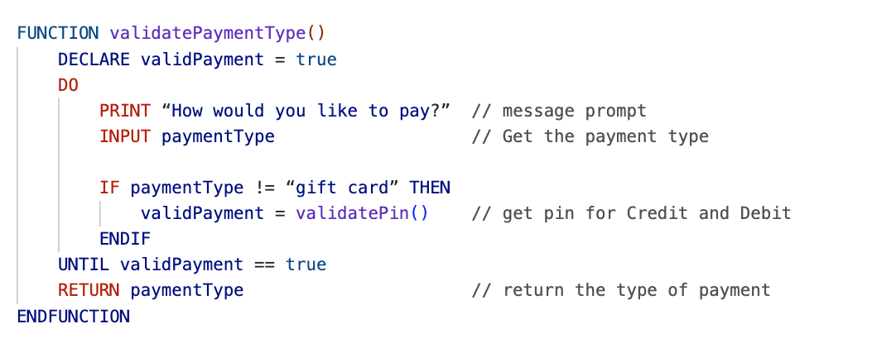
And we can update our program to look like this:

12-MAIN: with FUNCTION scanItems() and FUNCTION validatePayment Type()
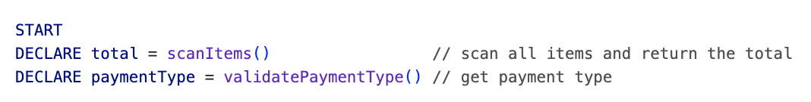

Process Payment
The last thing to do is to process the payment based on the user’s payment type. We need the final total and the payment type so that we can deduct the total from the gift card, bank account, or credit card.
13 – MAIN: with payment processing (and FUNCTION scanItems() and FUNCTION validatePaymentType())
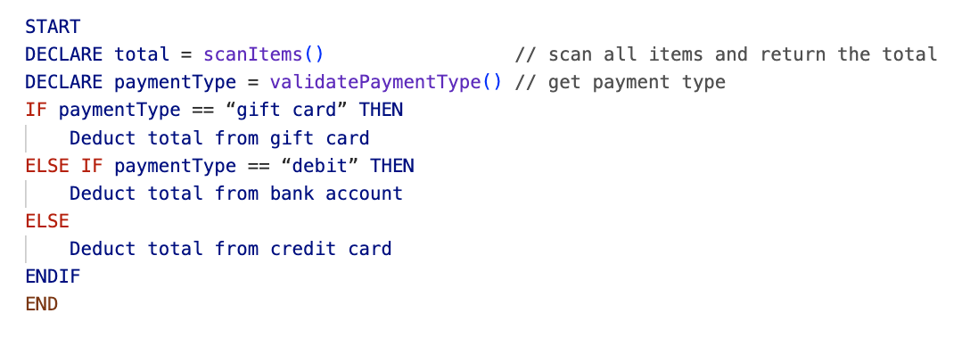

Once again, we could remove this processing code to a function. In the new function, we will need two parameters: the amount to deduct and where to deduct it from (paymentType).
14 – FUNCTION processPayment(amount, paymentType)
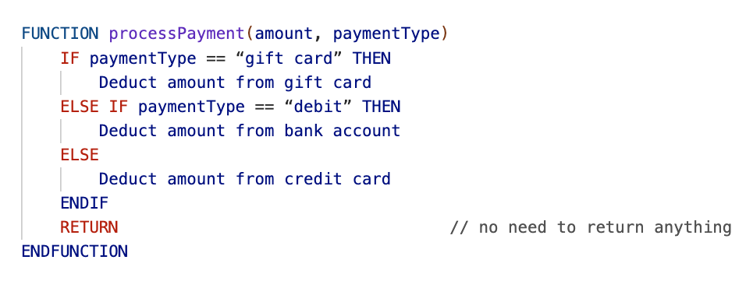
Now at last we can finish updating our program to be much cleaner and more modular.
15 – MAIN: completed
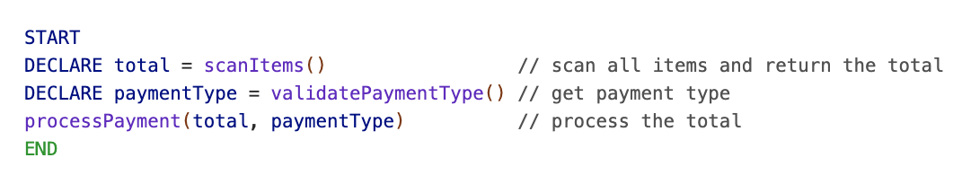
Completed Version


